Question-06-JDBC

Question -10-Ftp

Question-udv

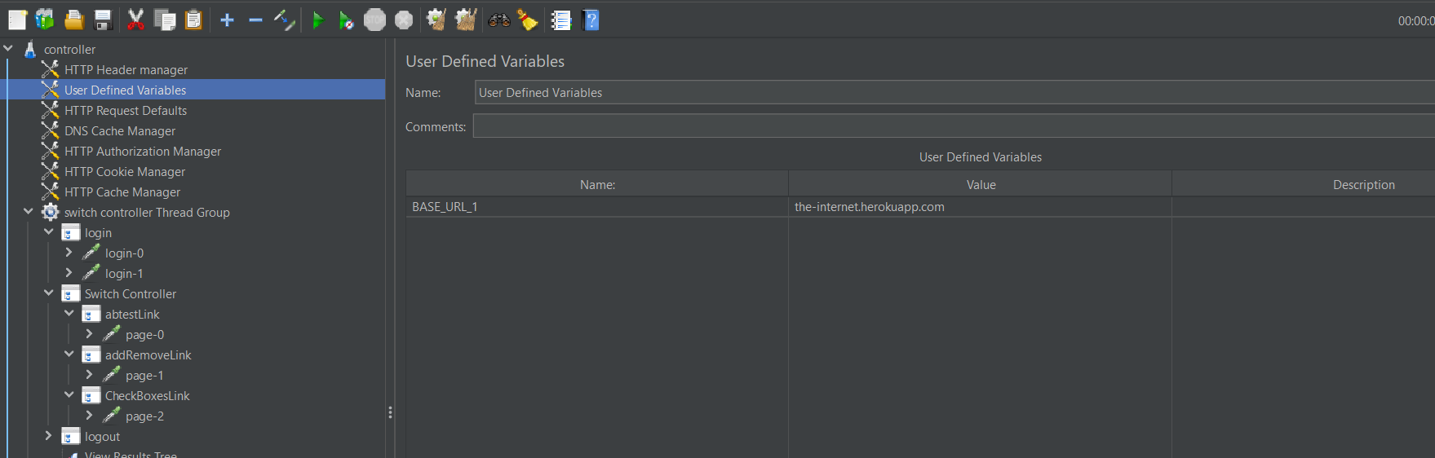

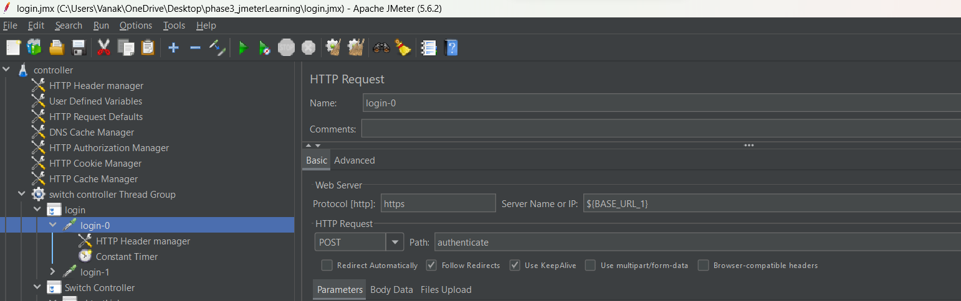

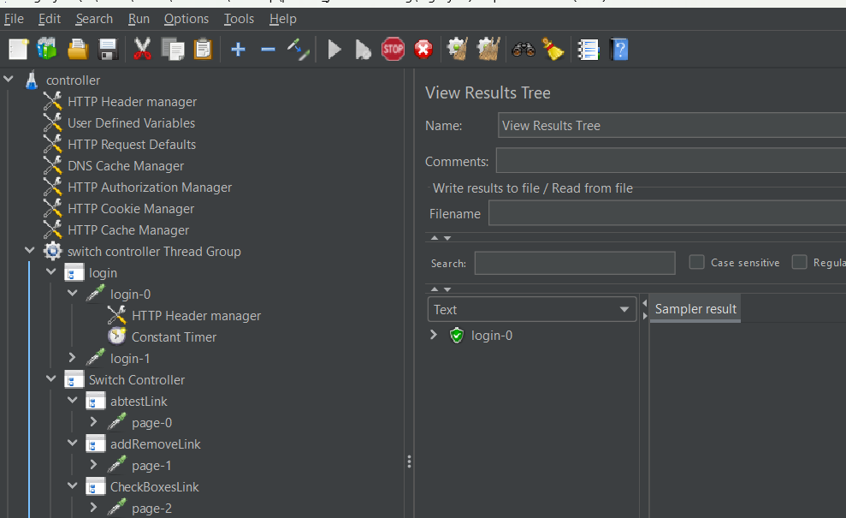

Question 01-http